Junction Networks
OnSip Hosted PBX TAPI Driver

Overview
The OnSip PBX TAPI Driver provides the ability to integrate with Windows telephony applications that support TAPI. TAPI, Telephony Application Programming Interface, is a standard developed by Microsoft for Windows applications to integrate with telephone services. For an overview of TAPI, see http://en.wikipedia.org/wiki/Telephony_Application_Programming_Interface.
One of the more common Windows applications that supports TAPI is Microsoft Outlook. In Outlook, a phone number in a Contact record can be dialed directly from the application. See the Section Outlook Configuration for details on how to configure Outlook.

Installation and Configuration
The installation program is responsible for installing the TAPI driver in Windows. After the install is complete, the following configuration screen is displayed.
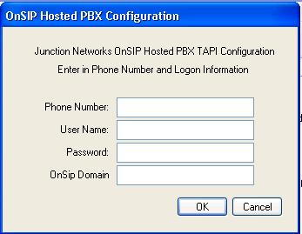
Enter the following values …
- Phone Number – enter your OnSip phone number. This is used only for display purposes by some TAPI applications.
- User Name – enter your OnSip account user name, e.g. “bobjones”
- Password – enter your OnSip password
- OnSip Domain – enter the domain for your OnSip account, e.g. “mycompany.onsip.com”
If Cancel is pressed during the installation, then the TAPI driver will not be installed correctly. See Section Manual Installation of TAPI Driver for details on how to complete the installation.
To access this configuration dialog in Windows, do the following steps…
- Open the Control Panel
- Double click on the Phone and Modem Options option

- The Phone and Modem Options dialog is displayed.

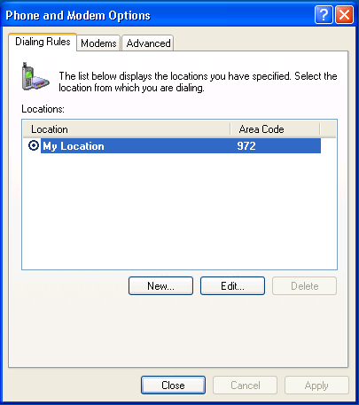

- Click on the Advanced tab

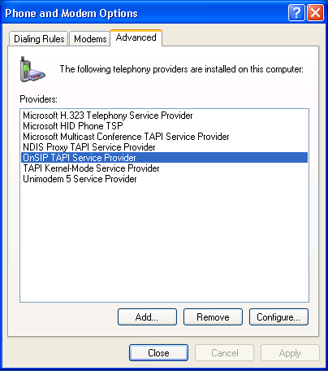

- Select the OnSip TAPI Service Provider item, and then click the Configure button. The OnSip Hosted PBX Configuration dialog will be displayed. Here the values can be changed as necessary. It may be necessary to restart the Windows TAPI application to accept the new settings. If the OnSip TAPI Service Provider is not an option in the Advanced dialog, then see Section Manual Installation of TAPI Driver regarding installing the TAPI driver.

General Operation
The OnSip TAPI driver provides limited telephony integration to the PBX due to it is integrating with an existing phone, and actually not working as a phone itself. For example, the TAPI driver is not able to answer an incoming call, but it is able to notify the user of the call and caller-id if available.
When placing a phone call via TAPI (e.g. Outlook integration), the call is placed using a 2 step process. First, the TAPI driver sends a request to the PBX to dial the phone number. The PBX responds by creating an incoming call back to the user to start the call process. After the call is answered by the user, then the PBX will proceed with the final step of dialing the requested party.
The TAPI driver is able to hang up calls only when a call is active and connected. If an outgoing call is ringing, or an incoming call is ringing, then the TAPI driver is not able to hang up the call. The user will be required to hang up using the phone.
As mentioned before, the TAPI driver is not able to answer incoming calls, or place the phone on speakerphone to answer the call. The call must be answered using the phone.

Outlook Configuration
Outlook provides an option to dial Contact numbers. For example, to dial a number while in the Contact list, right click on an entry and select Call Contact. Or, while in a Contact view, click on the Call button in the toolbar. When the Call option is selected, the following window is displayed…
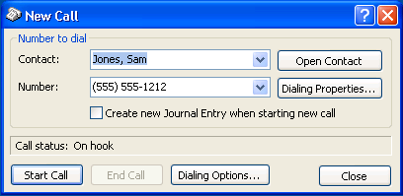
To select the OnSip TAPI driver to dial the number, click on the Dialing Options… button. The following dialog will be displayed. Select the OnSip Hosted PBX in the Connect using line option. Click on the OK button.
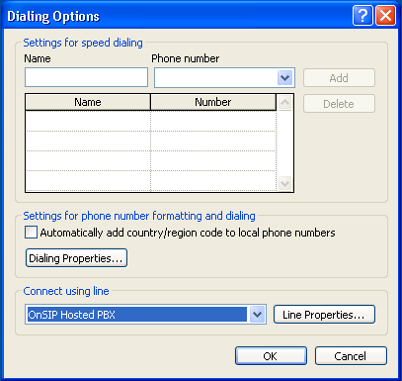
After this configuration, Outlook should save the settings for future calls. To dial the number, click on the Start Call button in the New Call window. As discussed in Section General Operation, an incoming call from the PBX will be created first. Answer the call, and then the PBX will continue the dialing request.

Manual Installation of TAPI Driver
If the install program failed to install the TAPI driver successfully, or if the user pressed Cancel in OnSIP Hosted PBX Configuration dialog, then it may be required to manually complete the TAPI driver install (or optionally attempt to re-install using the installation program).
- Follow the steps in Section Installation and Configuration until you get to the Advanced dialog. If the OnSip TAPI Driver is not displayed in the list of providers, then it is not installed.
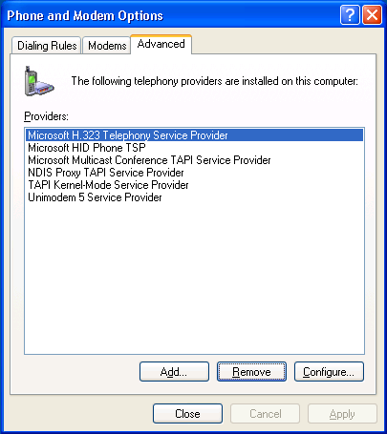
- Click on the Add button
- The list of available uninstalled TAPI drivers will be displayed
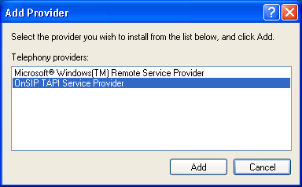
- Select the OnSip TAPI Service Provider in the list and click on Add. If the OnSip option is not in the list, then the TAPI driver files have not been installed. Please try to install again using the installation program.
- The OnSip Hosted PBX Configuration dialog will be displayed. Enter in the configuration values as described in Section Installation and Configuration

